

(All rights reserved)

**Interns**: Evans Acheampong and Josiah Lansah

**Course of study**: Computer Engineering and Computer Science

# **Instructor:** Douglas T. Ayitey

# **Date:** October 31st, 2022

**DAILY INTERNSHIP REPORT**

**DAY 9**

**PRATICAL MACHINE LEARNING PROJECTS WITH ARDUINO NANO BLE 33 SENSE**

* **GESTURE RECOGNITION USING ARDUINO NANO 33 BLE SENSE (THIRD PHASE)**

# [**EXPORTING DATA FROM ARDUINO SERIAL MONITOR TO A CSV OR TXT FILE**](https://forum.arduino.cc/t/how-to-export-data-from-arduino-serial-monitor-to-a-csv-or-txt-file/354651)

**Introduction**

Data Streamer is a two-way data transfer for Excel that streams live data from a microcontroller into Excel, and sends data from Excel back to the microcontroller.

To get data from a sensor into an Excel workbook, connect the sensor to a microcontroller that is connected to a Windows 10 PC or Windows 11 PC. Excel’s Data Streamer add-in also needs to be enabled, and a workbook needs to be opened.

Classrooms can be modernized with live data to transform how students model modern scientific and engineering practices.

Excel’s Data Streamer add-in supports capturing, visualizing, and analyzing real-time sensor data in Excel.

Data Streamer empowers students with a simple way to move data from the physical world in-and-out of Excel’s powerful digital canvas. With a sensor, a microcontroller (Arduino), and Excel, Data Streamer introduces students to the worlds of data science and the internet of things (IoT).

**Goals and objectives**

* Exploring practical applications of the project such as remote physiotherapy in future projects.
* Exporting data from Arduino’s serial monitor to excel for processing via PuTTY.

**Hardware and Software Required**

* An [Arduino Nano 33 BLE Sense](https://store.arduino.cc/nano-33-ble-sense) board
* A Micro USB cable to connect the Arduino board to your desktop machine.
* To program the board, we used the [Arduino IDE](https://www.arduino.cc/en/main/software).
* Excel with Data Streamer add in
* PuTTy software
* Microsoft Data Streamer.

# **How Data Streamers Work**

Data Streamer connects to a data source which can be a serial device, such as the Arduino Nano 33 Ble Sense microcontroller, or a Windows 10 app via a UWP (Universal Windows App) App Service. The data source collects data and packages it into a CSV format and sends the data at a frequency to Data Streamer. Data Streamer displays the data into an Excel worksheet. Data can also be sent from Excel to the device or app.

**Note:**

There are several mechanisms and applications that can be used to extract data from Arduino’s serial monitor to excel (as a csv file format). The simplest way is using a software that acts as a serial monitor and can save the data. The most commonly used is PuTTY.

**Using PuTTY**

**Procedure**

1. Install putty:  
   sudo apt-get install putty putty-tools
2. Run Putty.

[[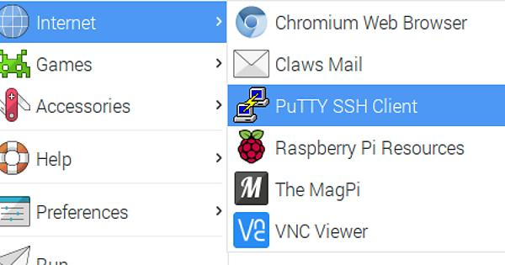](https://imgur.com/a/Dx695)](https://imgur.com/a/Dx695)

1. in Putty select serial and specify the right port:
2. then on the left under session go to the logging. select the printable output. and then specify the right address and file name for the output file:

[[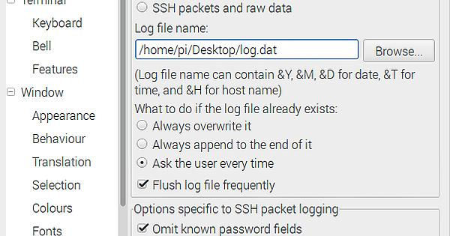](https://imgur.com/a/OLL7q)](https://imgur.com/a/OLL7q)

5.Then everything in the terminal will be recorded to the file in a csv format.

**Note**

The code used is the same as in the previous report

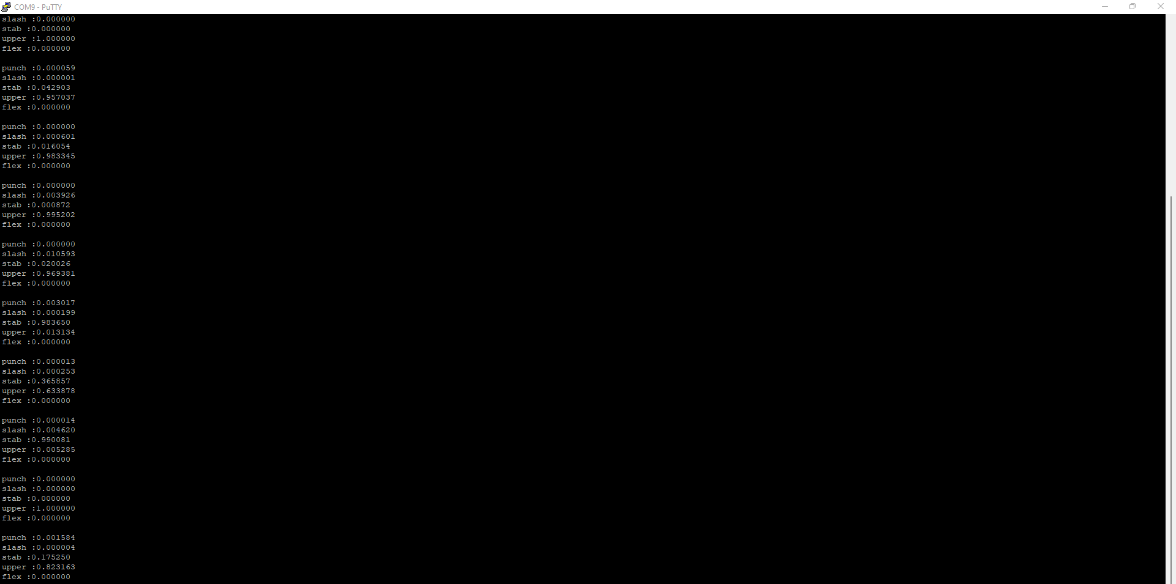

After extracting and saving the data using PuTTY, Excel can then be used to for several different applications

**Result**

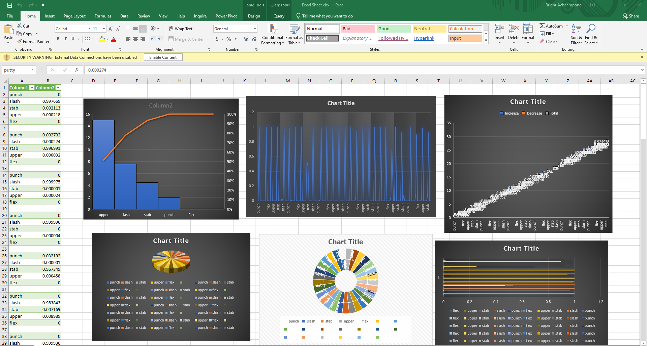

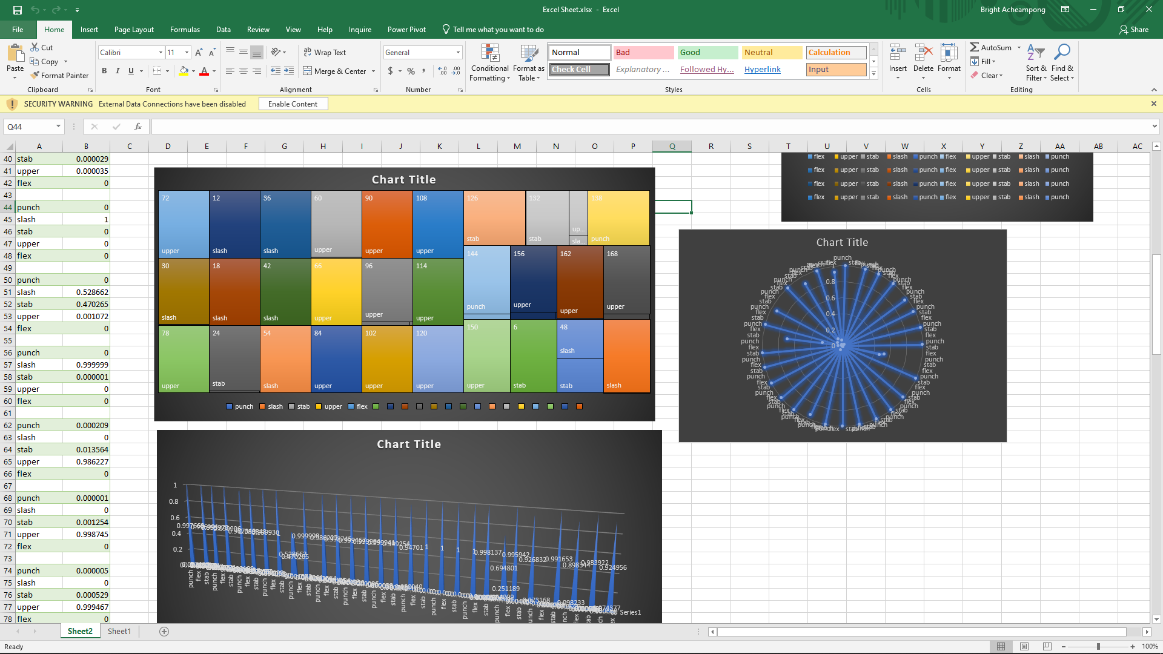

**Project Setbacks**

Directly connecting the Arduino Nano 33 Ble Sense to Excel via the Microsoft Data Streamer was not feasible as it does not support Nano boards mostly. The board is easily detected by the Excel data streamer but unfortunately does not obtain the data from the serial monitor.

**Possible Solutions**

Via a third-party apps such as PuTTY, we managed to both extract and save the data from the Arduino serial monitor to a csv file format that can be accessed by Excel for processing.

**Conclusion**

Further development using tech gloves and other means of technology, one’s gestures can be accurately recognized and applied in areas like gyms and fitness as well as remote physiotherapy.

**References**

[1] <https://forum.arduino.cc/t/how-to-export-data-from-arduino-serial-monitor-to-a-csv-or-txt-file/354651>

[2] <https://forum.arduino.cc/t/cant-get-arduino-nano-33-ble-senses-data-on-excel-data-streamer/886081/8>

[3] <https://forum.arduino.cc/t/cant-get-arduino-nano-33-ble-senses-data-on-excel-data-streamer/886081/17>

[4] <https://www.hackster.io/HackingSTEM/stream-data-from-arduino-into-excel-f1bede>

[5] <https://learn.microsoft.com/en-us/microsoft-365/education/data-streamer/connecting-serial-devices>

[6] <https://www.electromaker.io/project/view/export-data-from-arduino-to-excel-sheet>

[7] <https://nerdytechy.com/how-to-export-data-from-arduino-to-excel/>